C64 – Control Port Switch & Rapid-Fire Rev. 1

Module Description

Most C64 games require the joystick being connected to Control Port 2. Some games, especially those written in the early years of the C64, want the joystick on Control Port 1. To save the hassle of connecting the joystick back and forth, this joystick switch is does it on pressing a button. The selected port is displayed with an LED. The POTX and POTY signal for the paddles is switched as well.

Also, a rapid-fire function is implemented, which is synchronized to the fire button. That means, it starts firing immediately after the fire button was pressed (the maximum delay is 1 ms) at an adjustable frequency. This way, an optimized frequency can be set for every game individually.

The micro controller, which is used in this project is a Pro Micro. They are available for cheap on Ebay and from other online shops, they can be programmed with the free Arduino Software and only a Micro-USB cable is required for the in-system programming of this controller. A I²C connection allows to connect an OLED display to visualize the fire rate.

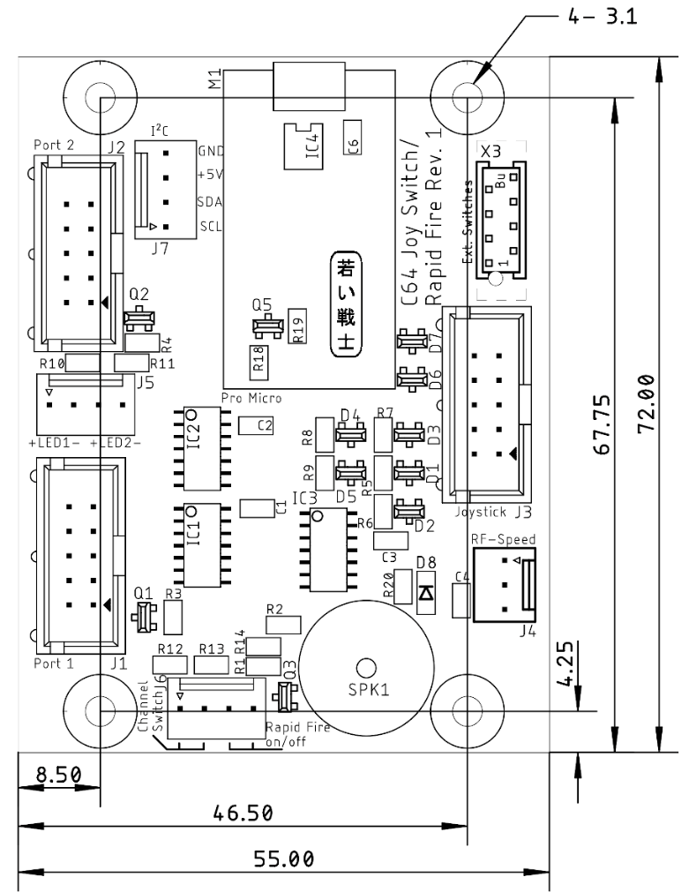

Figure 1: Dimensions of the PCB

A 3D printed case is provided with the project data.  
  
For future expansions, a serial (I²C) EEPROM (IC4) can be installed as a non-volatile memory. Also, the connector X3 is not required.

# Programming the Pro Micro

The *.ino Sketch needs to be compiled and programmed into the Pro Micro module. This is fairly simple. Only a Micro USB cable is required. Make sure, that the cable is a full USB cable.

Required software:

* Arduino IDE
* Adafruit GFX Library (<https://github.com/adafruit/Adafruit-GFX-Library>)
* Adafruit SSD1306 Library (<https://github.com/adafruit/Adafruit_SSD1306>)
* The actual software (joysw_rf.ino)

The two libraries should be installed first. This is accomplished within the Arduino IDE: Tools → Manage Libraries. Search for the respective library and click Install (in case the library is not INSTALLED).

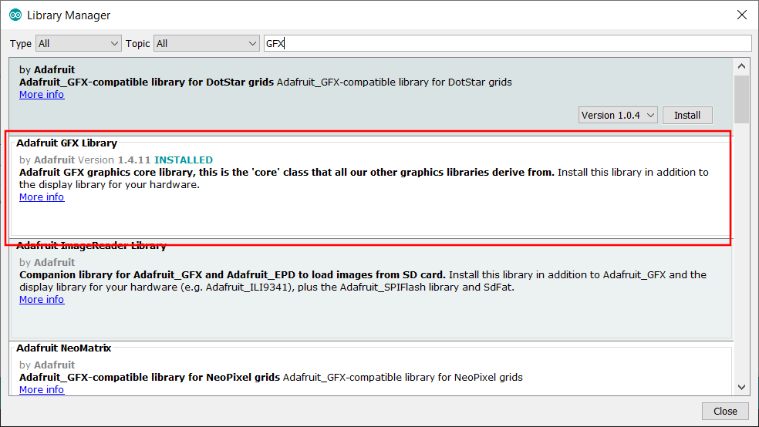

Figure 2: The Adafruit GFX Library in the Library Manager

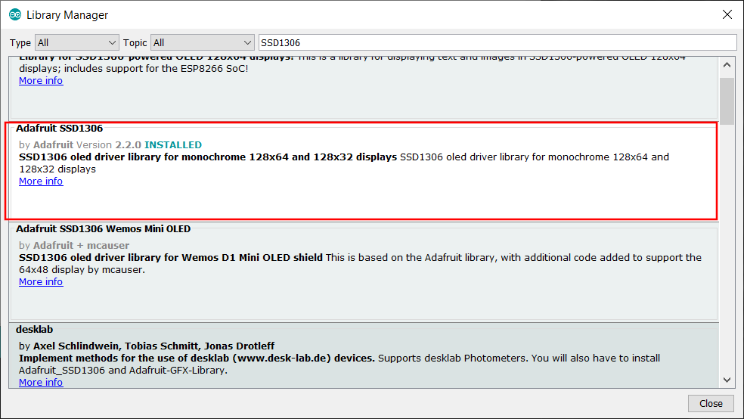

Figure : The Adafruit SSD1306 Library

Those libraries are required for the OLED display.

Next is selecting the type of Arduino. The Pro Micro is acting like a Leonardo. So in the Arduino IDE, you have to select Tools → Board → Arduino Leonardo.

Now make sure, that Pro Micro is connected to the PC via the USB cable (Micro USB). It does not need to be installed in the Control Port Switch. It is powered via USB.

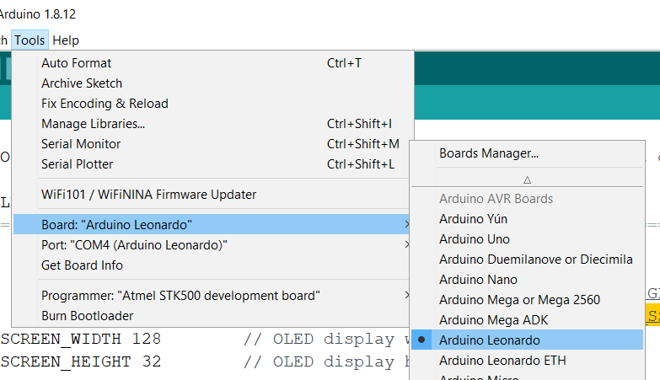

Figure 4: Setting up the board type (Leonardo)

After connecting the Pro Micro, the PC should report a new device is connected. The Pro Micro’s programming interface acts as a serial interface (COM-Port). If not, there might be a problem with the drivers or the Pro Micro is broken.

Now, try to find the COM-Port number, that the Pro Micro is configured as:

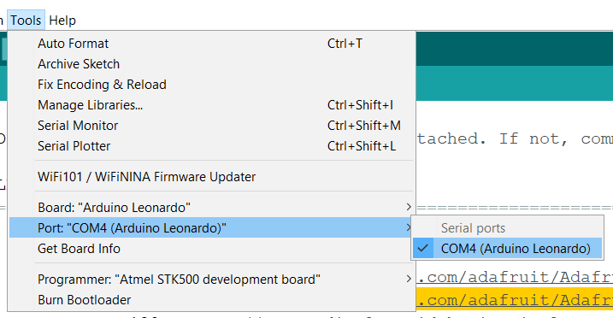

Figure 5: Selecting the COM-port

In Tools → Port, this COM-port should be visible. Select it. The COM-port is the serial channel, the Arduino IDE is communication through with the ATmega 32u4 micro controller on the module.

Now you can load the Sketch into the Arduino IDE (File → Open…). The Sketch is the source code of the program. It needs to be compiled (to create a machine program, which the processor understands). In the Arduino IDFE, it is very much simplified. You do not need to care for make-files etc. like in other development environments for micro controllers. If you are not into this topic, Arduino is for you.

You can even edit the source code. In case you do not want to connect a display (which is recommended), you can put // in front of the #define OLED directive. This makes a comment out of it, so it is not effective anymore. You will see a // comment at almost every line. Feel free to look though it, you might find it interesting. Programming is no witchcraft!

So, to compile and upload the sketch, click the right arrow icon at the top left of the Arduino IDE.

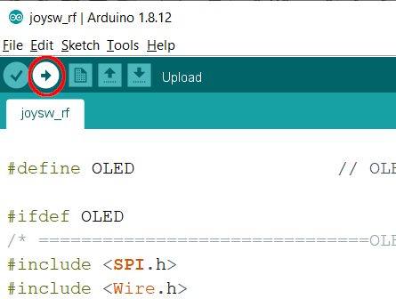

Figure 6: Compiling the Sketch and uploading (right arrow)

If all libraries are installed, the correct board type and COM-Port is selected and the Sketch is unmodified, the code should compile and upload without any error messages.

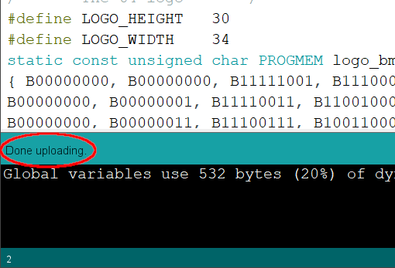

Figure 7: The Upload is done

So, look out for “Done uploading”, like shown in Figure 7. If you don’t see this message, you should read the error messages, which are displayed in the bottom of the window.

# Wiring the Device

## Crimping

Crimping is the preferred way of making cables, the connections are of a good quality (if the crimping carried out well). Unfortunately, it requires some dedicated tools. Fortunately, there are tools available for a fair price. Good results can be accomplished with the Engineer PA-20 and PA-09 tools. The IWISS IWS-2820 is a cheaper alternative, the results are acceptable.

Those tools are two pass tools. That means, the wire crimp and the isolation crimp have to be carried out in two consecutive passes. I prefer the “wire crimp first” method. There are plenty video tutorials about crimping on Youtube. I also plan to write an essay about crimping on my website (<http://tech.guitarsite.de>). This is a future project.

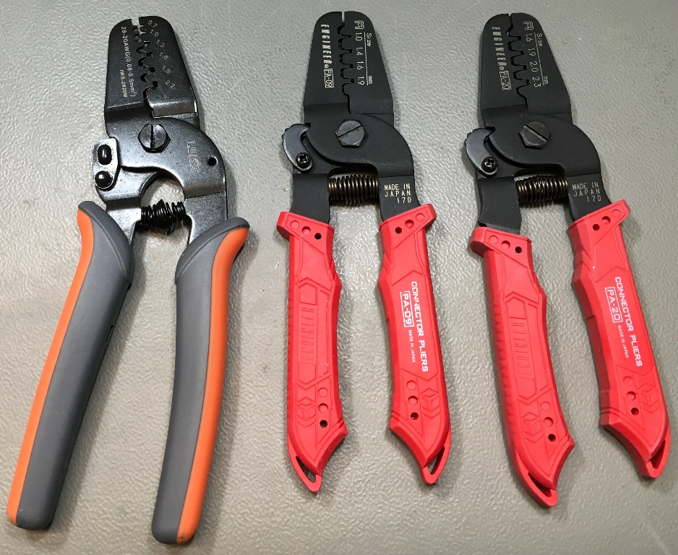

Figure 8: My crimp tools (from left to right: IWS-2820, PA-09, PA-20)

After 25 years in industrial engineering, I prefer locking connectors. The widely popular DuPont connectors are also acceptable for hobby projects. They might need to be secured with a drop of silicon glue (hot glue might work, but is harder to separate, if required).

Direct soldering of the wires onto the board, is also a working method, if you don’t have any crimp tools or don’t want to invest in them. It is not really great and it is hard to separate the components of the built, if required.

## Cables

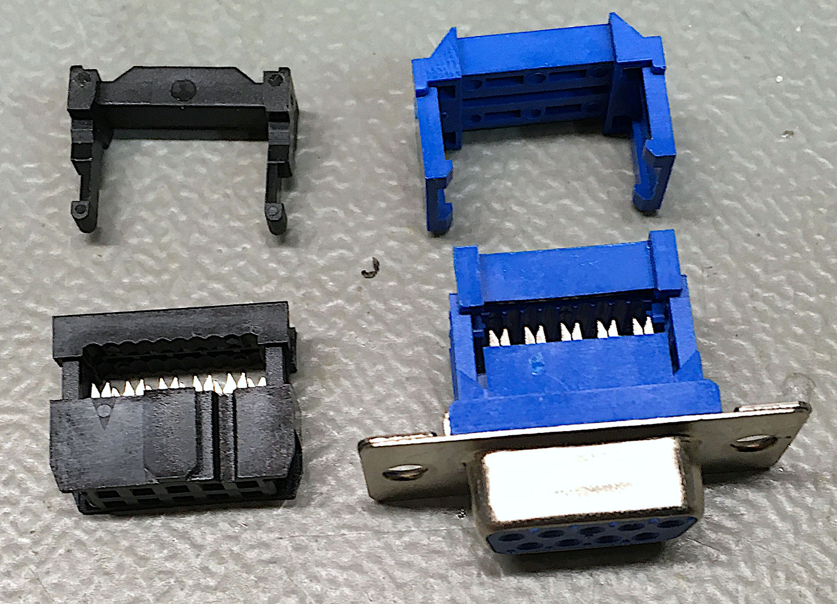

Figure : 2x5 and DSub IDC connectors and strain reliefs

There are three ribbon cables, two for the control ports, one for the joystick input. Both types of connectors are IDC ([Insulation Displacement Connectors](https://en.wikipedia.org/wiki/Insulation-displacement_connector)). This means, no soldering required, easy make. The little blades on each pin will penetrate the insulation of each wire of the ribbon cable and make a reliable contact with the conductors. It is a technology, which is established since the 1970s.

You don’t even need a special tool for making the cables, just a (little) wrench (Figure 10). There is a strain relief for both connectors, which is installed last. First, you cut the ribbon cable to length. Then insert the ribbon cable and align to the opposite side of the connector. Keep in mind, that installing the strain relief will cause a 180° turn (Figure 11). So, insert the cable from the opposite side that you finally want the cable to leave the connector. Pin 1 is marked. The wire 1 is also marked on a ribbon cable.

All D-Sub 9 connectors only have 9 pins, the IDC connectors have 2x5 (=10) pins. Thus the 10th wire has to be separated before the cable is inserted (Figure 12) in the D-Sub and finally clipped off.

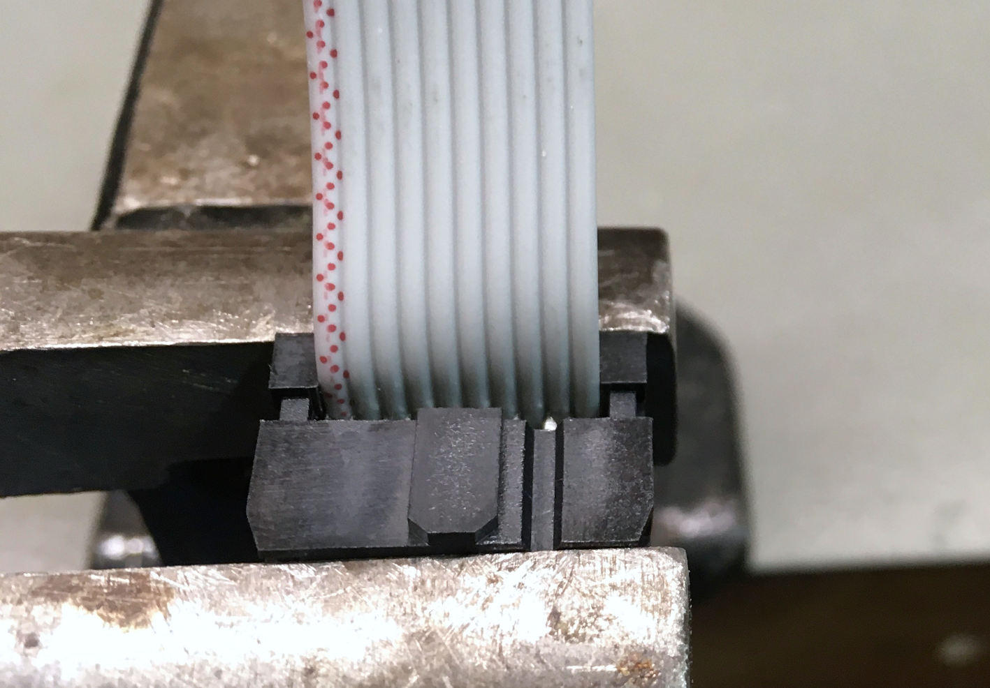

Figure 10: IDC connector before being compressed in a wrench

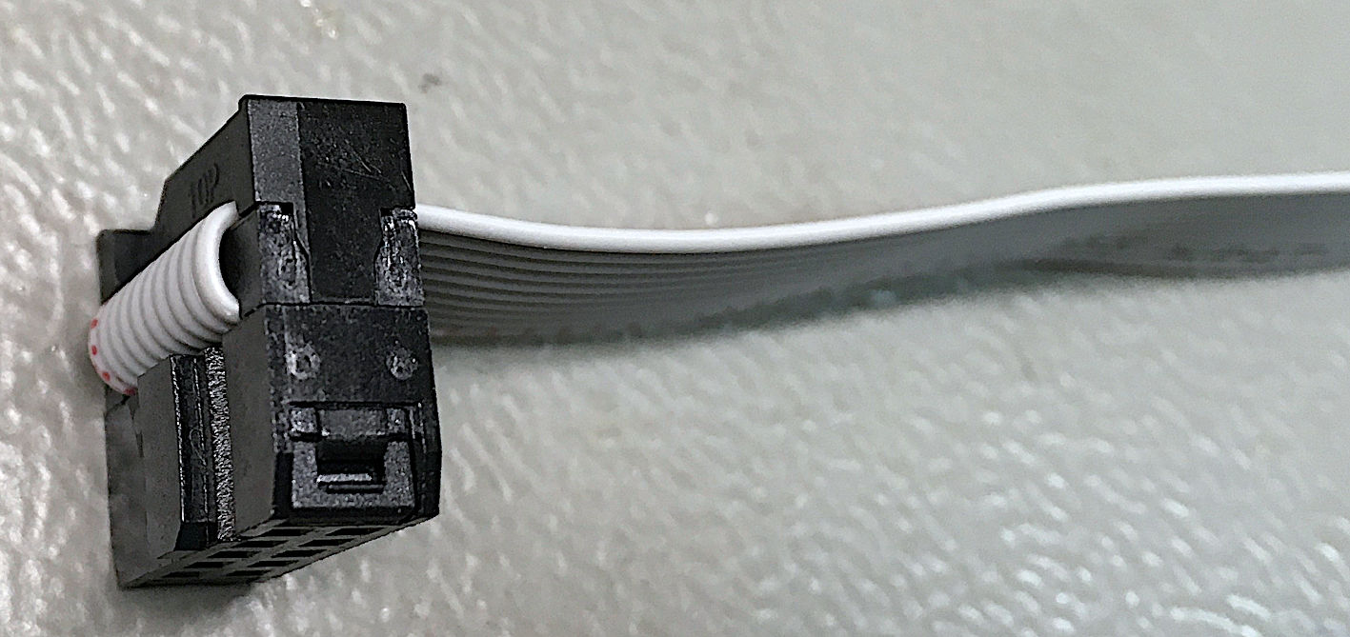

Figure 11: Side view after installing the strain relief

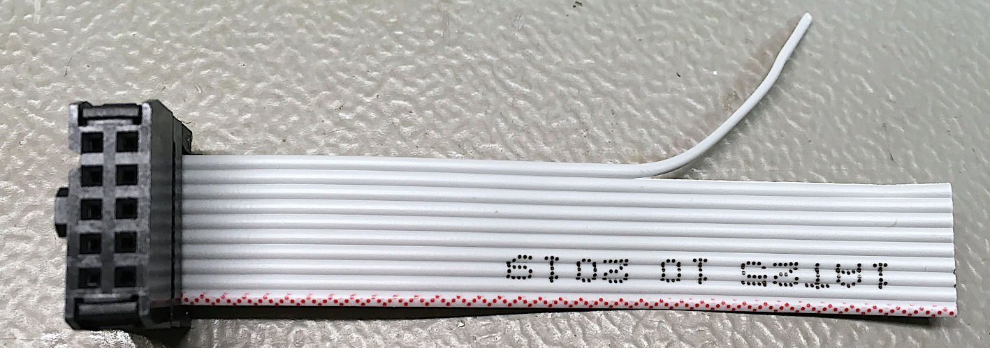

Figure 12: Separated 10th wire of the ribbon cable

Keep in mind, that pin 1 is in a deferent position on male and female D-Sub connectors. On a female connector, the pin numbers are usually shown on the contact face.

The required ribbon cables look like this:

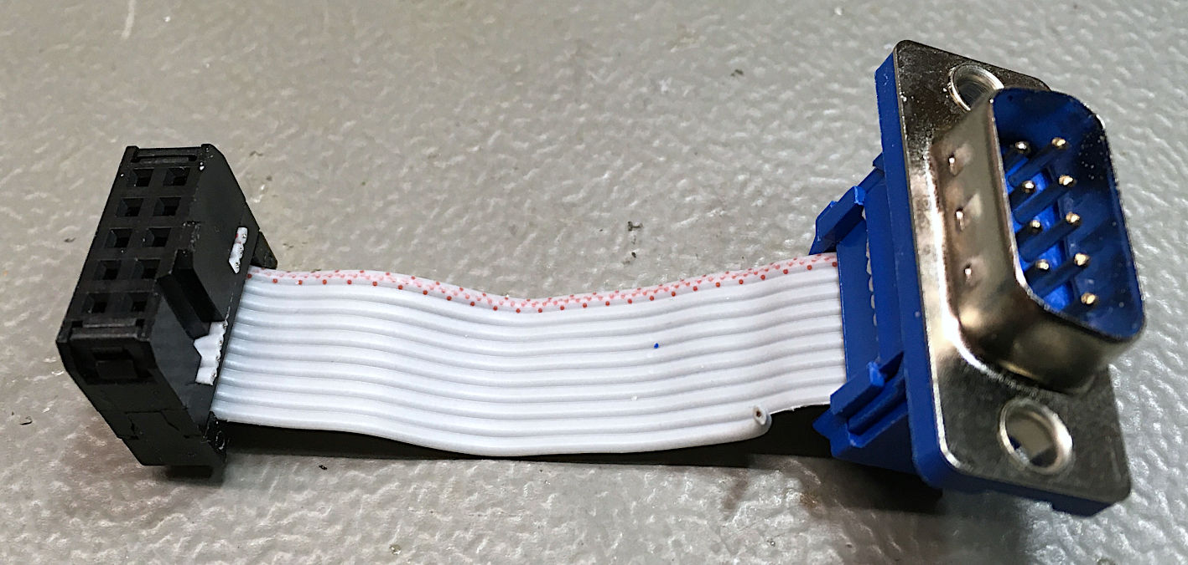

Figure 13: Joystick Input cable: Male D-Sub, 8cm ribbon cable

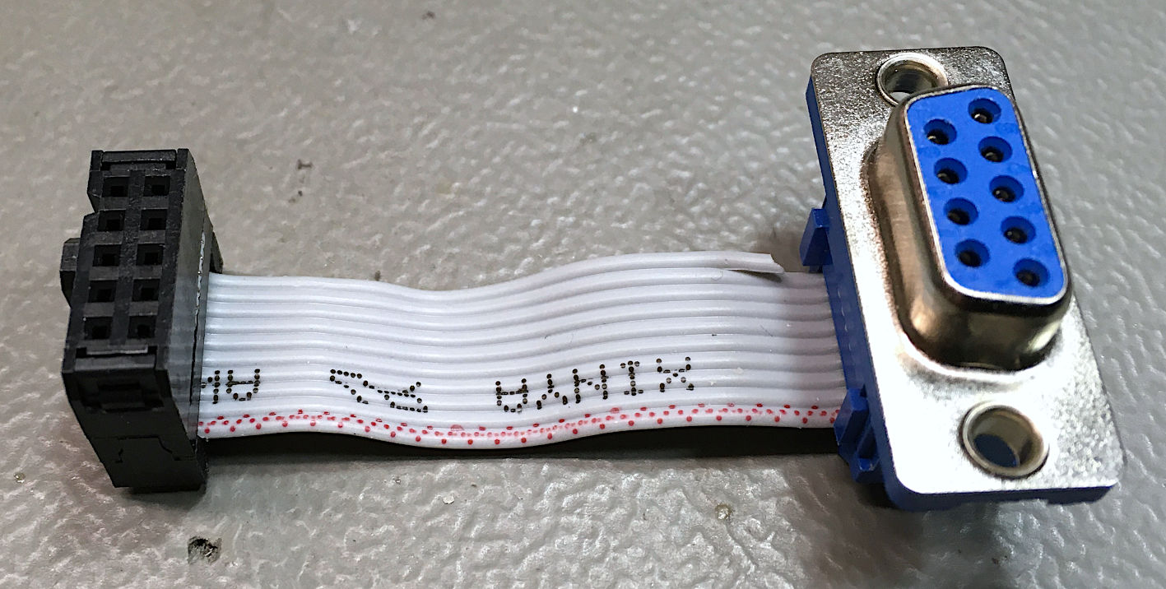

Figure 14: The output cables: female D-Sub, 8cm ribbon cable

Please note the different orientation of the coding notch in Figure 13 and Figure 14. Also, the marked wires (1) of the ribbon cables are on opposite sides. The cable shown in Figure 14 is required twice.

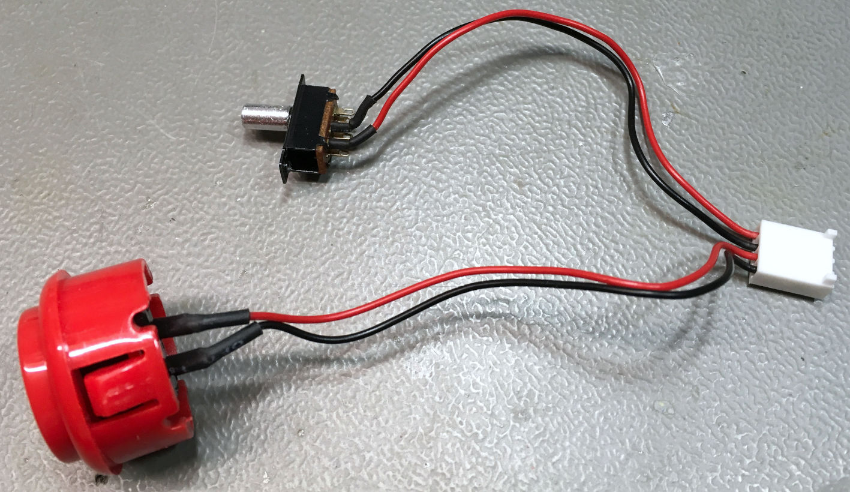

Figure 15: The cable with the rapid-fire button and the channel select switch

The rapid-fire button is sold as “**30mm** arcade button” on ebay or AliExpress. The switch is a panel mount slide switch, the screw holes (M2) pitch is 19mm. The cable length is 12cm for both switches.

It is advised to use shrinkable sleeve the shown connector is a Molex 22-01-2041 crimp housing (refer to the /Switches). The crimp dies used for the crimp terminal (also for DuPont crimp terminals) are 1.6mm for the wire crimp and 1.9mm for the insulation crimp.

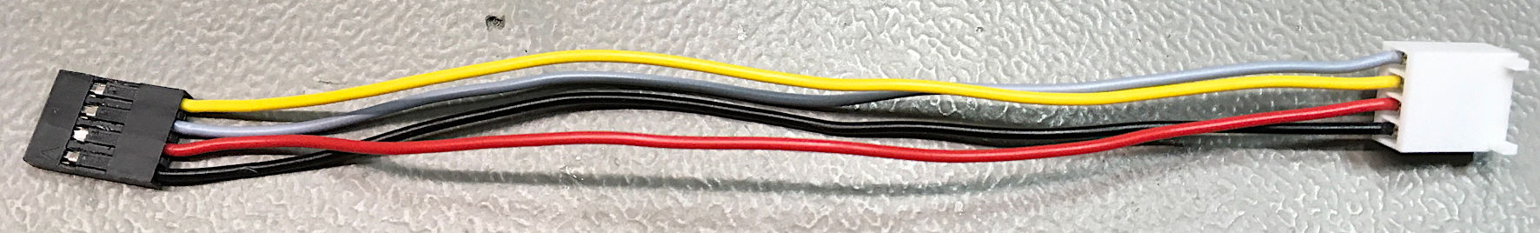

Figure 16: The display cable

|  |  |  |  |
| --- | --- | --- | --- |
| DuPont | Signal | Color | Molex |
| Pin 1 | GND | Black | Pin 4 |
| Pin 2 | +5V | Red | Pin 3 |
| Pin 4 | SDA | Yellow | Pin 2 |
| Pin 3 | SCL (also “SCK”) | Grey | Pin 1 |

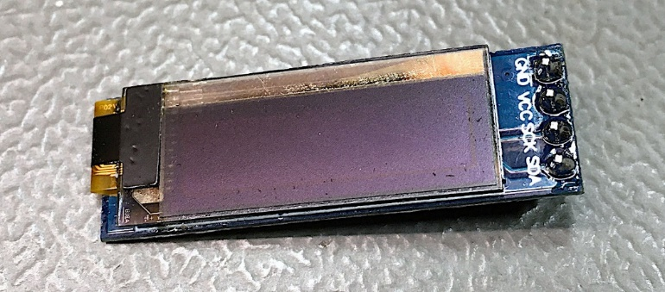

Figure 17: 0.91" OLED display

The display is a 0.91” OLED with I²C bus and an SSD1306 controller. The measures of the display PCB are 38mm x 12mm.

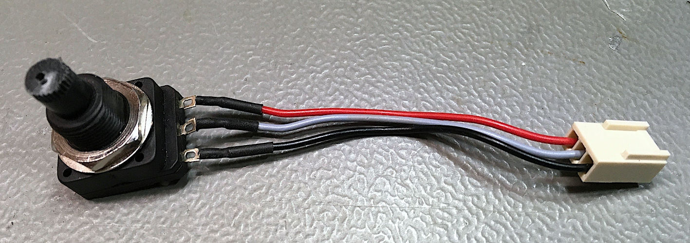

Figure 18: Potentiometer cable

The crimp housing is a Molex 22-01-2031. For the connection, please refer to chapter Pinouts/Fire-Rate Potentiometer.Length 6.5cm.

|  |  |  |  |
| --- | --- | --- | --- |
| Pot | Signal | Color | Molex |
| Clockwise | +5V | Black | Pin 1 |
| Tap | RF-Speed | Red | Pin 2 |
| Counter Clockwise | GND | Yellow | Pin 3 |

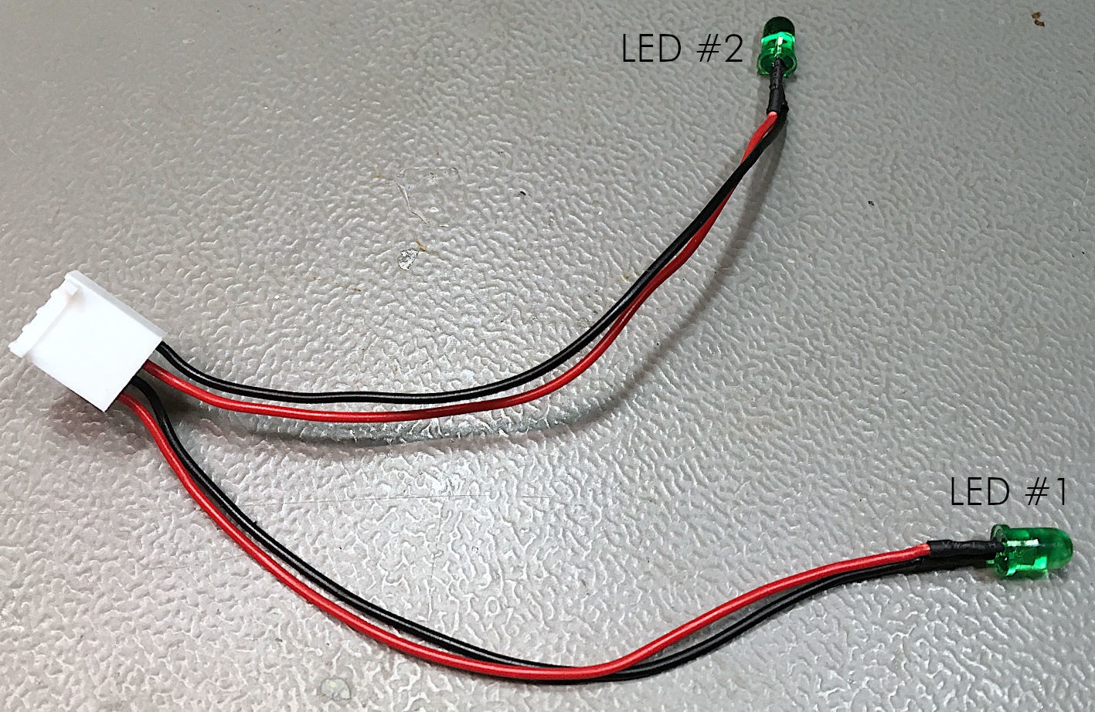

Figure 19: LED cable

Again, there is a Molex 22-01-2041 crimp housing (refer to Chapter Pinouts/LEDs). Note: The LEDs have a polarity. The anode (+) and the cathode (-) must not be confused. The cathode is marked with the flat side. Also, the cathode pin is shorter. It is advised to use shrinkable sleeves for the solder joints. Length: 8cm.

# Assembly

The 3D printed housing consists of three parts and a label. Also, some screws are required.

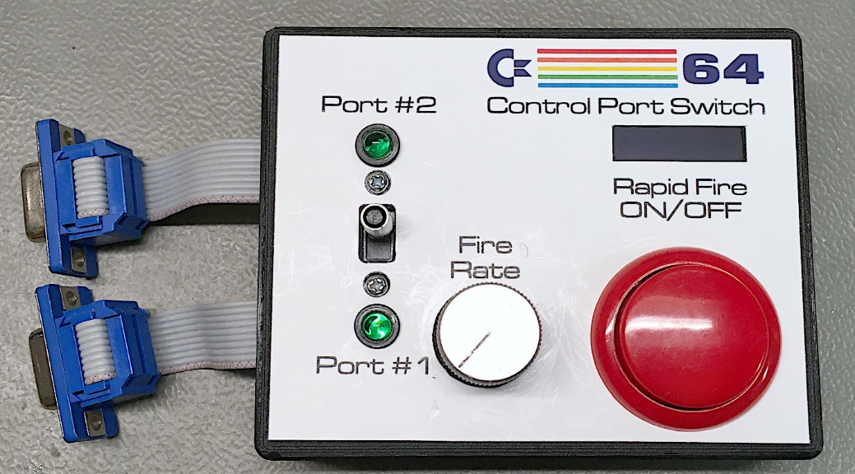

Figure 20: Top view of the completed Control Port Switch

The label is printed on a weatherproof outdoor sticker (I have used HERMA 9500) for laser printing (on my Samsung C1810W color laser printer). Other brands are also suitable. The foil sticks very well.

The top shell, bottom shell and display holder were printed with PLA filament.

Assembling the PCB is pretty straight forward. First populate the surface mount parts (SMD). The Pro Micro might require the pin headers being soldered. To get good and vertical connections, insert the pin headers into the socket strips into the PCB and solder the Pro Micro first. Then solder the socket strips in the PCB.

The through hole parts are soldered last.

Before mounting any parts in the top shell, the label should be installed.

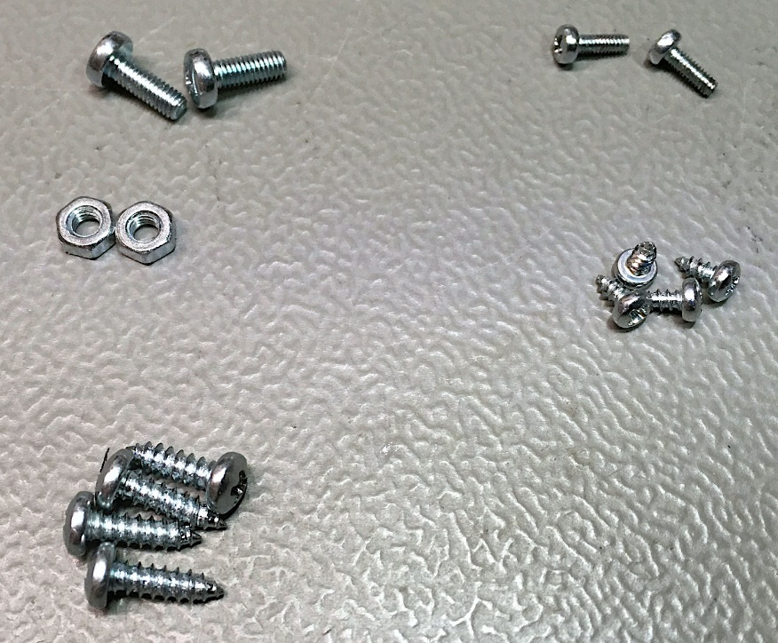

Figure 21: The required screws

The following screws are required

* 2x M3x8 and M3 nuts for the D-Sub connector (Joystick input). Non-Metric screws are possible.
* 2x M2x6 for the slide switch
* 4x C2.2x4.5 for the display holder
* 4x C2.9x9.5 for the case

The tolerances of the display cutout and the display holder are +/-0.5mm, so such a display should fit in, although the tolerances might be high. Nevertheless, the display should be handles with care. The glass is thin and breaks easily. So, make sure, the display fits before you (carefully) tighten the screws (4x C2.2x4.5). Refer to Figure 22.

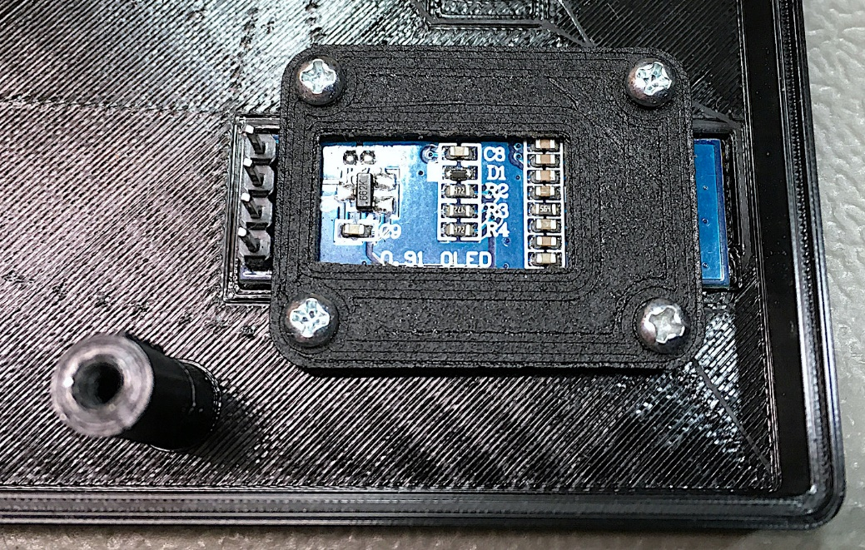

Figure 22: Mounted display

Mount the potentiometer. The pins should point inwards(Figure 23).

The cable with the arcade button can be mounted by inserting the slide switch through the hole. The arcade button snaps in place. There are different arcade buttons available, which might be slightly different. In case the arcade button sits lose, some hot glue can cure that. Do not apply the hot glues near the (open) sides, because it will block the button. Only apply it near the snap-in pins.

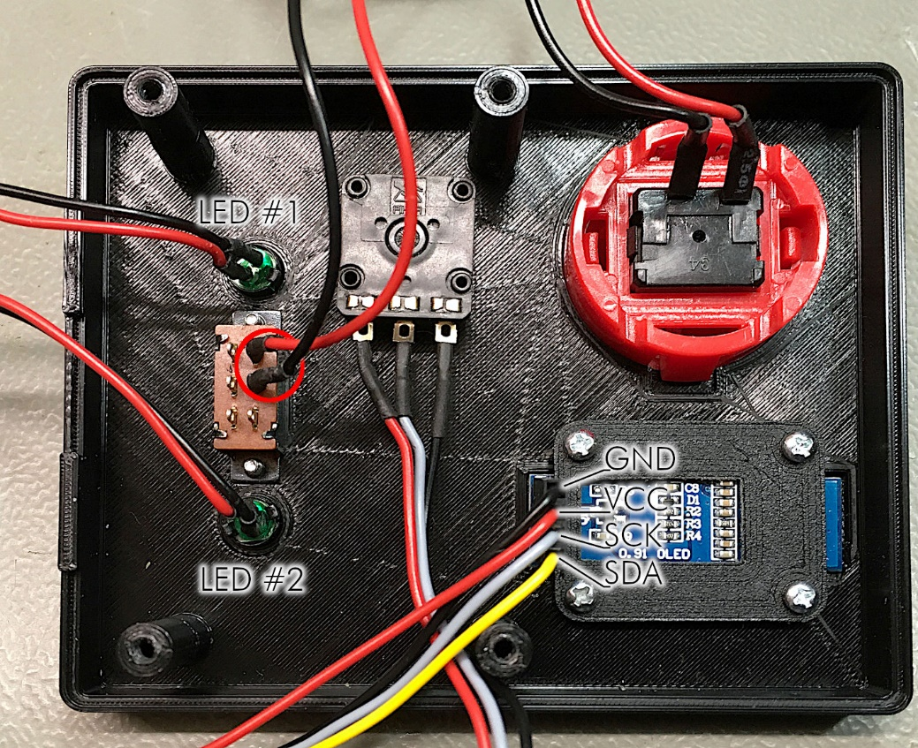

Figure 23: The completely assembled top shell

Fix the slide switch with two screws (M2x6). The two connected terminals of the slide switch should point to the side with the pot and the arcade button. Only this way, it will switch to Port #1 when slid downwards (red circle in Figure 23).

For the LEDs, snap in the LED holders and insert the LEDs. They could be confused, so make sure, that the LEDs are mounted in the place, they belong. Refer to Figure 19 and Figure 23.

Finally, mount the display cable. This can be oriented improperly. Refer to Figure 16 and Figure 23.

Assembling the bottom shell is not much work. The joystick input cable (“Male”) is screwed to the bottom with two screws (M3x8 and M3 nuts). Refer to Figure 24.

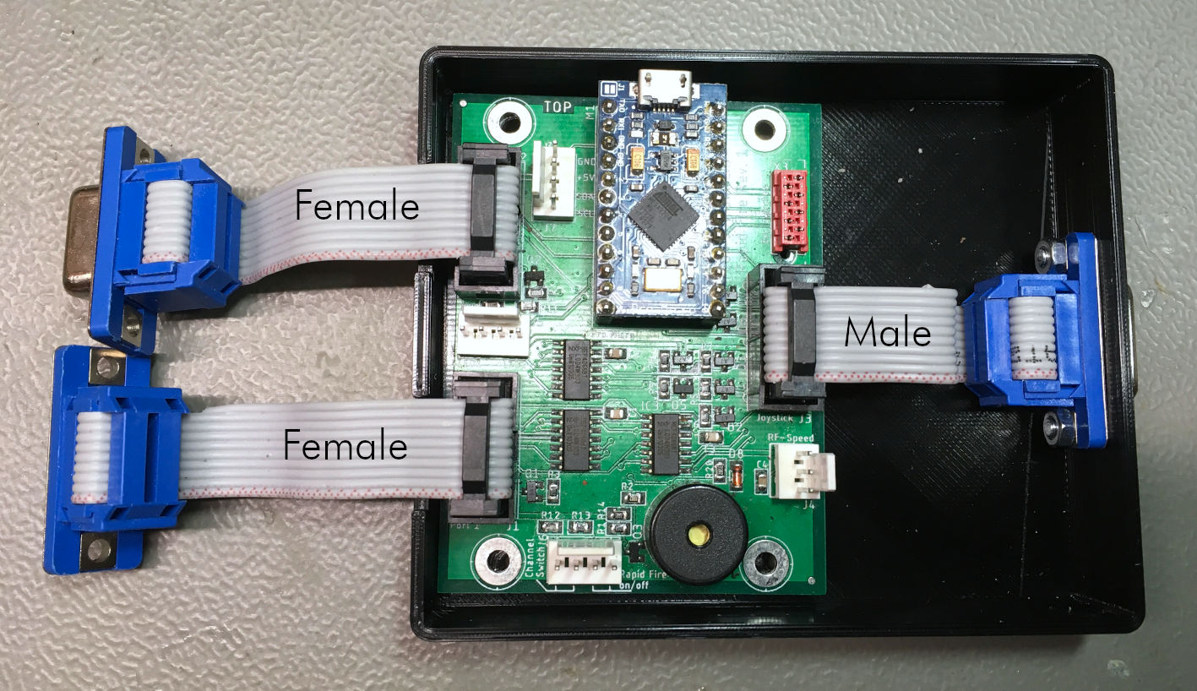

Figure 24: Assembled bottom shell

Put the PCB in place and connect the ribbon cables. The PCB is not yet held in place by screws.

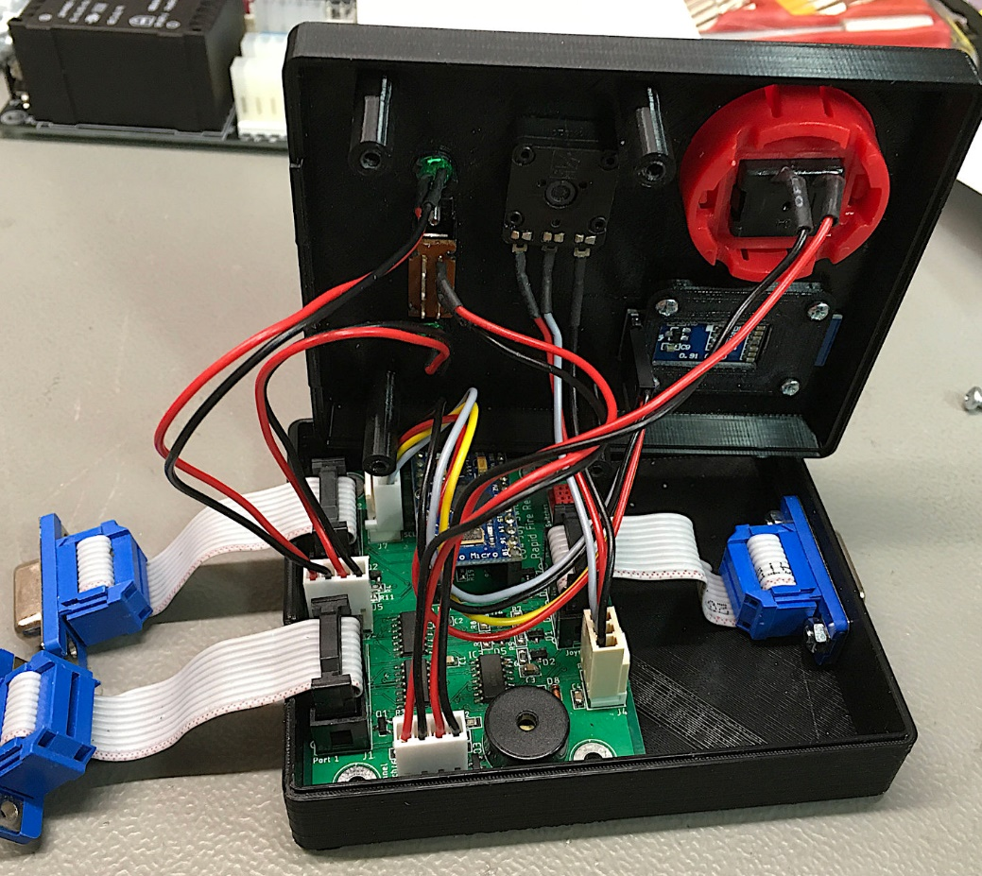

Figure 25: Connecting top shell and bottom shell

The cables from the top shell are now connected to the PCB. The space in the case is restricted and it might take some fiddling to close the case. Without cables being in the way.

Finally, the case is closed with the C2.9x9.5 screws. These screws are passing the mounting holes in the PCB and are screwed into the top shell mounting posts.

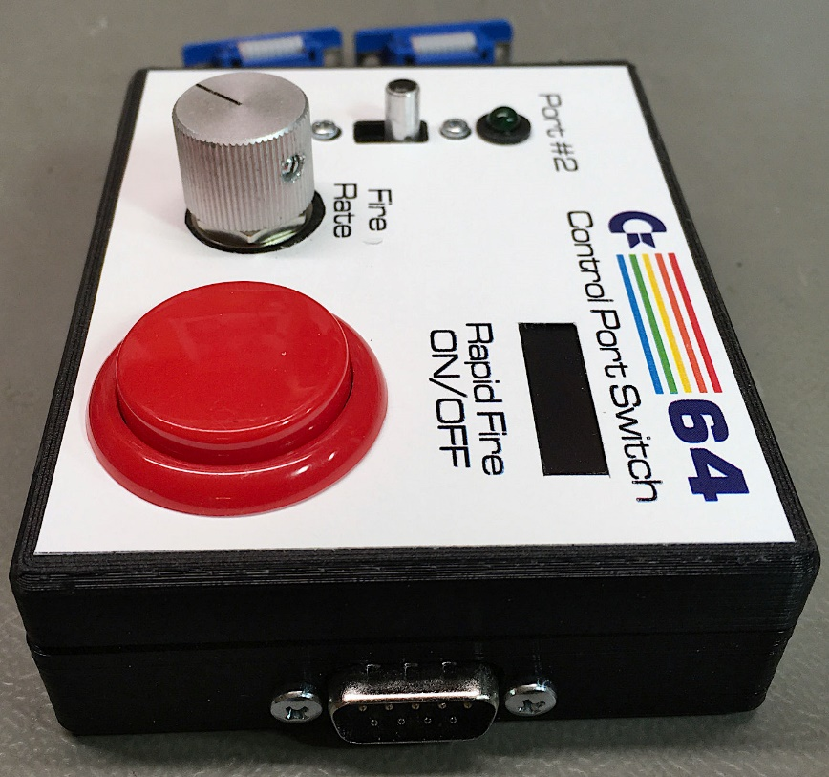

Figure 26: Finished Control Port Switch (side view)

# Test of the Control Port Switch

For testing, I have used the [Joytester II](https://csdb.dk/release/?id=170175), which can be found on csdb.dk.

Connect the Control Port Switch to the C64, then switch on the computer. The Control Port Switch will issue a beep (1/4 second). The display should first show the 64 logo, then a link to my website (sorry for advertising).

The port selector switch selects one port and the corresponding LED should light up. Sliding the switch to the opposite side should select the other port.

Pushing the arcade button should switch on the rapid-fire. This is displayed on the OLED display. The LED of the selected Port should blink while rapid-fire is on. The blink rate resembles the fire rate. Turn the pot CCW and the fire rate gets less (150 r/min is the minimum in the present software), turning the pot clockwise should increase the fire rate (1500 r/min is the maximum in the present software).

Now load the software and connect the joystick. The joystick should be active on the selected port. All four directions and the fire button should be tested for both ports. They should show some activity on the selected port only.

# Trouble Shooting

Make sure, that the cables are connected properly and that the single wires are not confused.

In case the device is dead (no sound, no light, no display), make sure, the Pro Micro is programmed.

Check the orientation of the ICs on the board, check the soldering.

# Pinouts

## Control Ports

J1 (Port 1) & J2 (Port 2) – 2x5 pin header (box connector) for a ribbon cable which connects via a D-SUB 9 (female) to the control port.

|  |  |  |  |  |  |
| --- | --- | --- | --- | --- | --- |
| **Pin** | D-SUB | **Signal** | **Pin** | D-SUB | **Signal** |
| 1 | 1 | JOY0 (up) | 2 | 6 | FIRE |
| 3 | 2 | JOY1 (down) | 4 | 7 | +5V |
| 5 | 3 | JOY2 (left) | 6 | 8 | GND |
| 7 | 4 | JOY3 (right) | 8 | 9 | POTX |
| 9 | 5 | POTY | 10 | - | n.c. |

## Joystick Port

J3 – 2x5 pin header (box connector) for a ribbon cable which connects via a D-SUB 9 (male) to the control port.

|  |  |  |  |  |  |
| --- | --- | --- | --- | --- | --- |
| **Pin** | D-SUB | **Signal** | **Pin** | D-SUB | **Signal** |
| 1 | 1 | JOY0 (up) | 2 | 6 | FIRE |
| 3 | 2 | JOY1 (down) | 4 | 7 | +5V |
| 5 | 3 | JOY2 (left) | 6 | 8 | GND |
| 7 | 4 | JOY3 (right) | 8 | 9 | POTX |
| 9 | 5 | POTY | 10 | - | n.c. |

## Fire-Rate Potentiometer

J4 – 3p. Molex 22-27-2031 (2,54mm pitch pin header, friction lock). Mating crimp housing 22-01-2031. Crimp terminal: 2478-TL/0850-0106.

Alternatively, a 2.54mm pitch standard pin header and a Dupont crimp housing and terminals can be used or the potentiometer is wired and soldered in without any connectors.

|  |  |  |
| --- | --- | --- |
| Pin | Signal | Note |
| 1 | +5V | Clockwise |
| 2 | RFSPEED | Tap |
| 3 | GND | Counterclockwise |

## Switches

J6 – 4p. Molex 22-27-2041 (2,54mm pitch pin header, friction lock). Mating crimp housing 22-01-2041. Crimp terminal: 2478-TL/0850-0106.

Alternatively, a 2.54mm pitch standard pin header and a DuPont crimp housing and terminals can be used or the switches are wired and soldered in without any connectors.

|  |  |  |
| --- | --- | --- |
| Pin | Signal | Note |
| 1 | /SWITCH | Switch for channel switching |
| 2 | GND | The other connection for this switch |
| 3 | /RF_ON | Switch for rapid-fire |
| 4 | GND | The other connection for this switch |

## LEDs

J5 – 4p. Molex 22-27-2041 (2,54mm pitch pin header, friction lock). Mating crimp housing 22-01-2041. Crimp terminal: 2478-TL/0850-0106.

Alternatively, a 2.54mm pitch standard pin header and a Dupont crimp housing and terminals can be used or the LEDs are wired and soldered in without any connectors.

|  |  |  |
| --- | --- | --- |
| Pin | Signal | Note |
| 1 | +5V | Anode of LED for Port 1 active |
| 2 | /LED1 | Cathode LED1, 330Ω resistor on PCB |
| 3 | +5V | Anode of LED for Port 2 active |
| 4 | /LED2 | Cathode LED2, 330Ω resistor on PCB |

## I²C-Bus

J7 – 4p. Molex 22-27-2041 (2,54mm pitch pin header, friction lock). Mating crimp housing 22-01-2041. Crimp terminal: 2478-TL/0850-0106.

The I²C bus provides a display connection. The total power consumption of the board, the display and the joystick should not exceed 100mA.

|  |  |  |
| --- | --- | --- |
| Pin | Signal | Note |
| 1 | SCL | I²C Clock |
| 2 | SDA | I²C Data |
| 3 | +5V | Supply voltage (I < 100mA) |
| 4 | GND | Ground |

## External Switches

X3 – MPE Garry 369-1-008 (MicroMatch 8p., female, THT).

This is an optional connector to operate this module with an external switch board (Project No. 112) or rotary encoder board (Project No. 118) from the Pi1541 Project. Both boards are suitable for +5V supply, except the LEDs, which then should remain not assembled.

|  |  |  |
| --- | --- | --- |
| Pin | Signal | Note |
| 1 | /SW1_IN | Select |
| 2 | /SW2_IN | Up |
| 3 | /SW3_IN | Down |
| 4 | /SWITCH | Channel Switching |
| 5 | /RF_ON | Rapid-fire on/off |
| 6 | - | Not connected |
| 7 | +5V | Power supply for external switches |
| 8 | GND | Ground |

# Links

* My github: <https://github.com/svenpetersen1965>
* My website: <http://tech.guitarsite.de/>
* Arduino IDE: <https://www.arduino.cc/en/Main/Software>
* The test software: <https://csdb.dk/release/?id=170175>
* A source of the OLED display: [AliExpress: 1pcs 0.91 inch OLED module 0.91" white/blue OLED 128X32 OLED LCD LED Display Module 0.91" IIC Communicate](https://www.aliexpress.com/item/32672327708.html?spm=a2g0s.9042311.0.0.715d4c4dBON0hL)
* A source of the arcade button: [AliExpress: 10 pcs Arcade 30mm Round Button Copy SANWA OBSF-30](https://www.aliexpress.com/item/10000014730221.html?spm=a2g0s.9042311.0.0.27424c4dlqOZNp)
* A source of the Pro Micro: [AliExpress: TZT Pro Micro ATmega32U4 5V 16MHz Replace ATmega328 For Arduino Pro Mini With 2 Row Pin Header For Leonardo Mini Usb Interface](https://www.aliexpress.com/item/32768308647.html?spm=a2g0o.productlist.0.0.e89c2562tYLsXM&algo_pvid=c0b3ad0d-9658-445a-b64a-f2e43cc06620&algo_expid=c0b3ad0d-9658-445a-b64a-f2e43cc06620-0&btsid=0b0a3f8115847030911474176e4470&ws_ab_test=searchweb0_0,searchweb201602_,searchweb201603_)

Note: The sources are one of plenty.